Prompt the user to enter the value to a variable at runtime

vi playbookvar2.yml

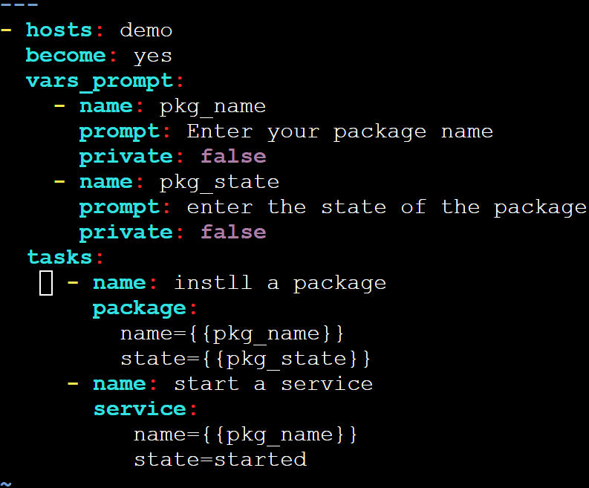

---

- hosts: demo

become: yes

vars_prompt:

- name: pkg_name

prompt: Enter your package name

private: false

- name: pkg_state

prompt: enter the state of the package

private: false

tasks:

- name: instll a package

package:

name={{pkg_name}}

state={{pkg_state}}

- name: start a service

service:

name={{pkg_name}}

state=started

################

ansible-playbook playbookvar2.yml